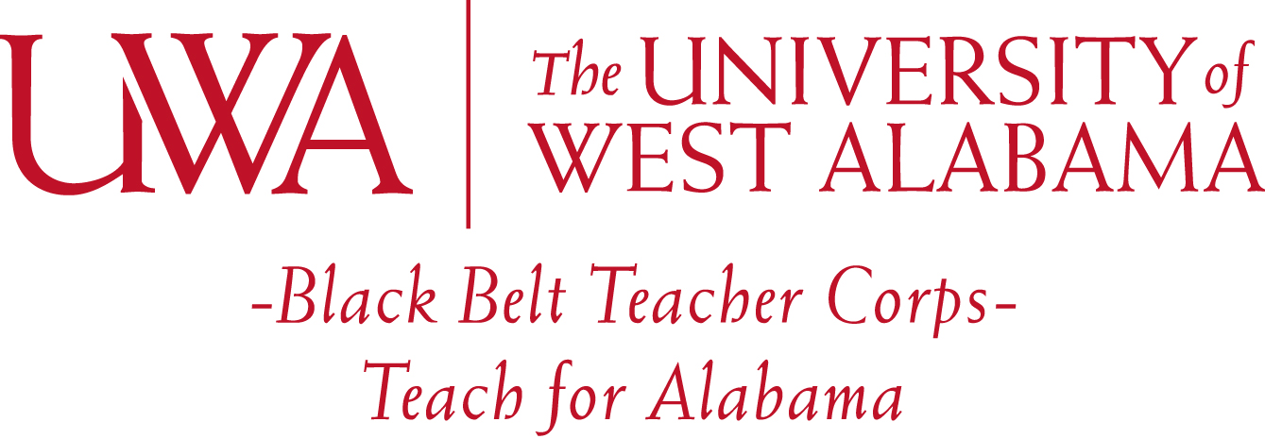

My name is Susan Hester, and I am the Director of the Black Belt Teacher Corps scholarship program. To impact more of our Black Belt region classrooms, I am inviting all University of West Alabama junior/senior education majors that meet eligibility requirements (see scholarship application) to apply. Each semester the scholarship is active, the award is $2,500.00 (up to a maximum of $10,000).
The teaching service commitment to receive this scholarship has changed! Now we are allowing our BBTC teachers to complete their required years of service in an Alabama Black Belt region public school, or an Alabama public school designated as rural, or an Alabama public school considered high-needs by the ALSDE.
Recipients are provided with opportunities for additional training and activities. For those BBTC scholars receiving the full scholarship, community service is also part of your commitment. I have money available for you to jump-start a community service project in a rural area or rural school setting.
There will be a sliding scale of the service teaching time required based upon the amount of scholarship awarded. Interns receiving one semester of scholarship funding ($2,500.00) must commit to teach for one (1) full calendar year within twelve (12) months of certification and receive ALSDE certification within six (6) months of the originally expected graduation date. Seniors receiving two semesters of scholarship funding ($5,000.00) must commit to teach for at least two (2) full calendar years within twelve (12) months of certification and receive ALSDE certification within six (6) months of the originally expected graduation date. Those receiving three (3) or four (4) semesters of scholarship funding ($10,000.00) must commit to all of the same stipulations, but the commitment to teach is for at least three (3) years. Full scholarship recipients ($10,000.00) will also complete a rural community service project ($1,000 granted to use as start-up money).
The Black Belt region counties that fit under this scholarship umbrella include: Lamar, Pickens, Sumter, Choctaw, Washington, Greene, Hale, Marengo, Clarke, Perry, Dallas, Wilcox, Monroe, Conecuh, Escambia, Lowndes, Butler, Crenshaw, Montgomery, Macon, Pike, Bullock, Russell, and Barbour. To check to see if the schools you are interested in teaching at are considered rural, please use this link: https://nces.ed.gov/programs/maped/LocaleLookup/
Simply enter the name of the school to search for its location and use the key to determine its designation. High-needs districts usually include schools that have critical teacher shortages, content area shortages, high poverty, low-performance, or large percentages teachers teaching without certification or outside of their certification field.

